Name____________________________ Solving Linear Systems Using Tables
An example of a system of linear equations in two variables x and y is the following:
 | y = 2x + 4 | Equation 1
 | y = −3x + 44 | Equation 2
A solution of a system of equations in two variables is an ordered pair (x, y) that is a solution of both equations. One way to solve a system is to use the table feature of a graphing calculator.
EXPLORE | Solve a system
Use a table to solve the system of equations above.
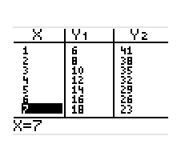  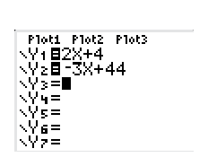  STEP 1 Enter equations  Press Y = to enter the equations. Enter  Equation 1 as y₁, and Equation 2 as y₂. | STEP 2 Make a table  Set the starting x-value of the table to 0 and the step value to 1. Then use the table feature to make a table.

STEP 3 Find the solution
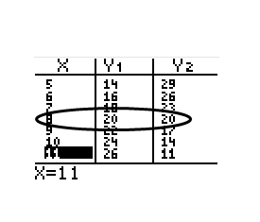
Scroll through the table until you find an x-value for which y₁ and y₂, are equal. Use this x-value and y-value to write an ordered pair. This is the solution of the system. The solution of the system is (8, 20).

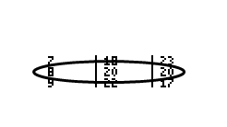
Solve each system of equations. For each system that has a single solution, show a table with the solution, a table row above it, and a table row below it like this:
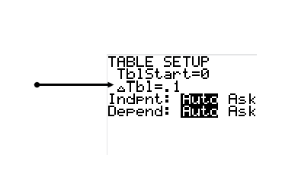

If you cannot find a solution, you may need to change your table
settings to tenths, or even hundredths. Change your table
increment, by pressing 2nd, TBLSET, like this:

If you still cannot find a solution, explain why not.

Solve each system. Show a table for systems that have a solution(s) or an explanation for systems that do not have a solution.
1) y = 3x + 14 2) y = -6x – 11 3) y = -3x - 4
y = 8x + 4 y = -3x – 5 y = -5x - 10

4) y = 4x – 29 5) y = -8x – 14 6) y = 4x + 12
y = -2x + 19 y = 9x + 3 y = -4x - 28

7. y = 2x + 5 8. y = 4x + 1 9. y = 3x – 3
y = -x + 2 y = 4x – 8 y = x + 1

10. y = 2x – 3 11. y = 2x - 4 12. 4x + 2y = 10 (Hint: solve for y)
y= x + 1 -2x + y = 1 (Hint: solve for y) y = 4x - 43

13. x + y = 11 14. -2x + y = 5 (Hint: solve for y) 15. 5x + 5y = 5 (Hint: solve for y)
-x – y = -11 y = -x + 2 5x + 3y = 4.2 (Hint: solve for y)

16. Is it possible for a linear system of equations to have exactly two solutions? Explain.
17. Why does the system in Exercise 13 have an infinite number of solutions?
18. Describe the table for a system of equations that has no solution.
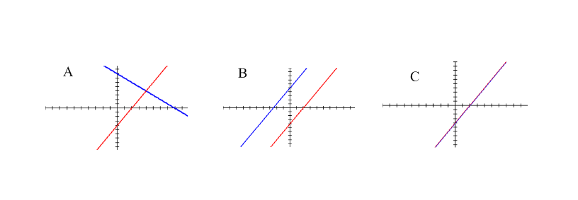
19. Match each number of solutions to its graph:
_____no solution _____one solution _____infinite number of solutions

